**Admin/User Details Maintenance:**

**Assumptions:**

* Records are present in the booking table, admin database table and user database table.
* Admin has the permission to remove user but can’t add any user.
* Admin can remove or add another admin.
* Admin has the access to view the booking details of the users but not to edit it.

**Functionalities:**

* OOALV Interactive Report
* Table Control
* Search Help
* Data Manipulation Screen  
   (Add, Update, Remove & Display User)
* Login Screen
* Adobe Form
* Messages
* Database Table
* Screen Painter
* Classes

**Navigation:**

Name - Rajat Goswami

**Screenshots:**

**User/Admin Details Homepage:**

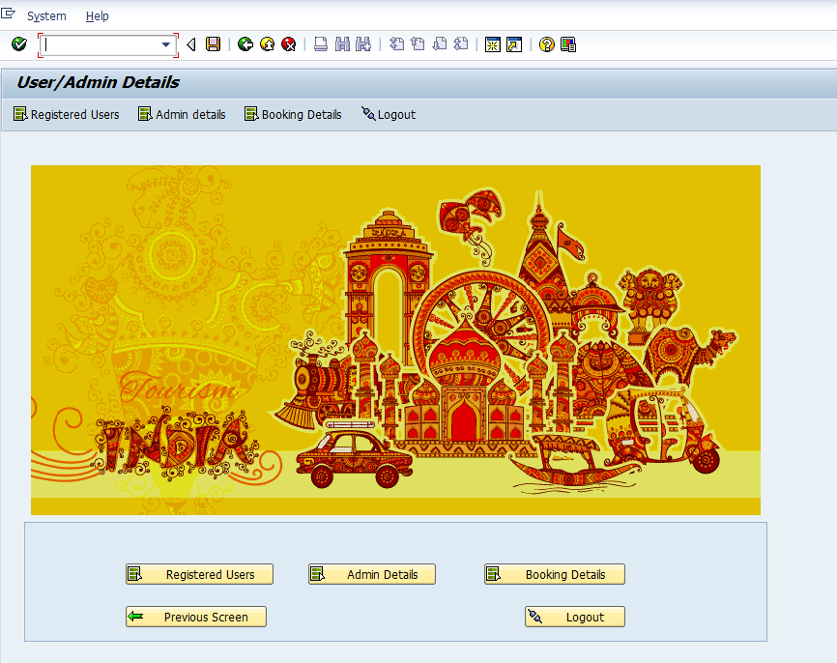

**OOALV Interactive Report:**

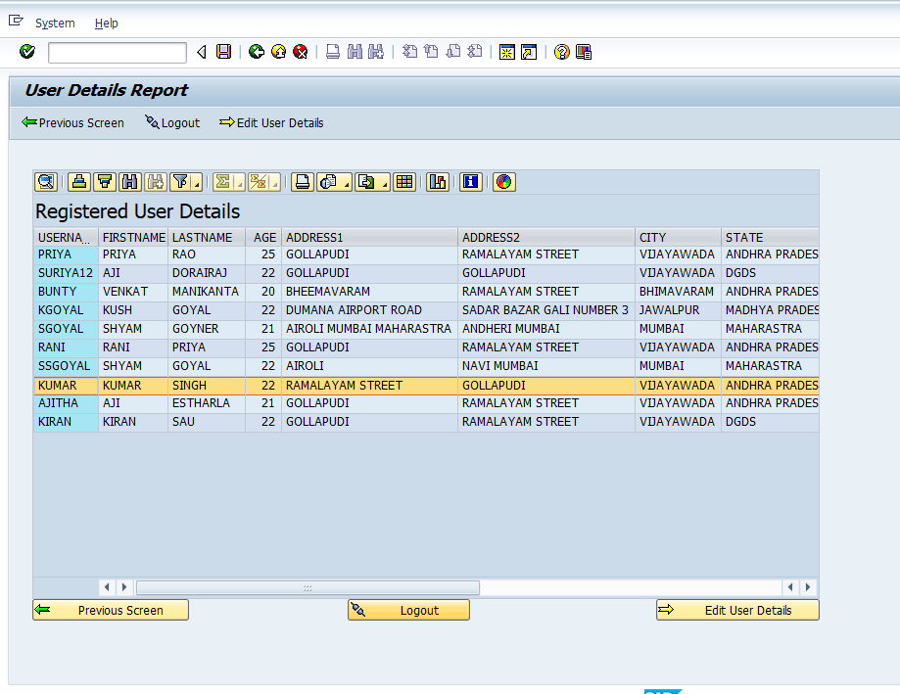

**User Details Manipulation Tab:**

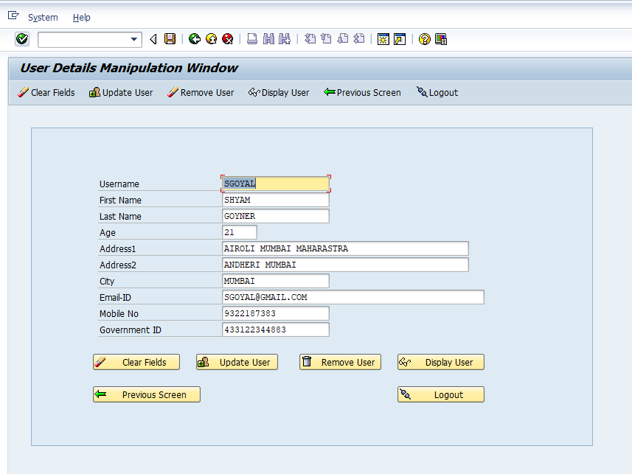

**Table control for Admin Details**

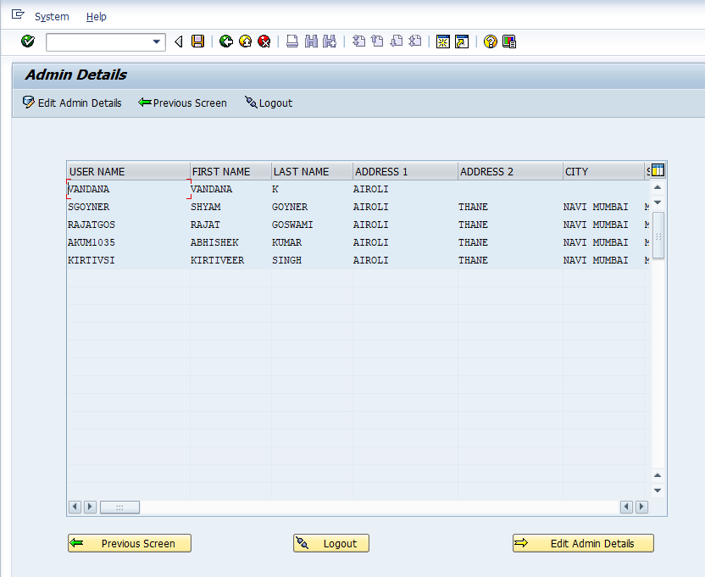

**Search Help for Username:**

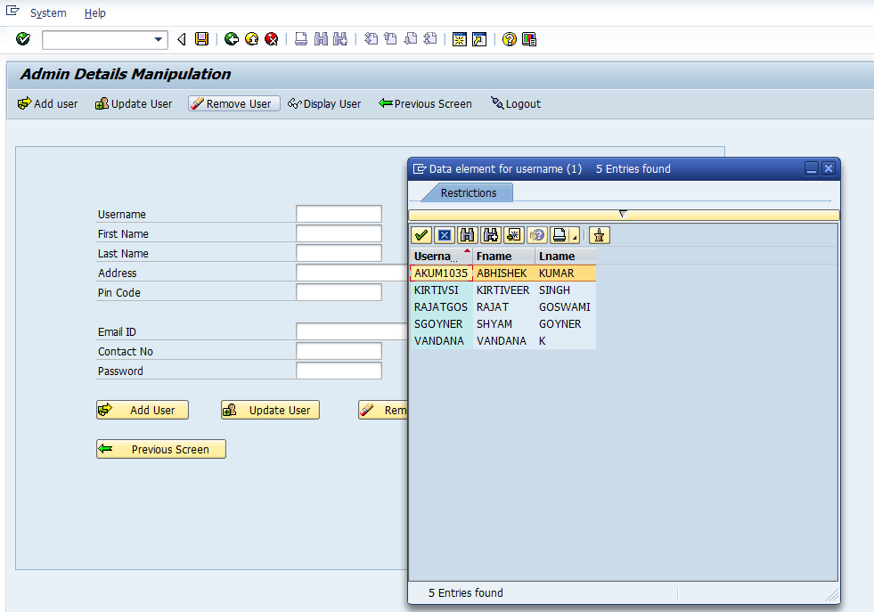

**Data manipulation screen for Admin:**

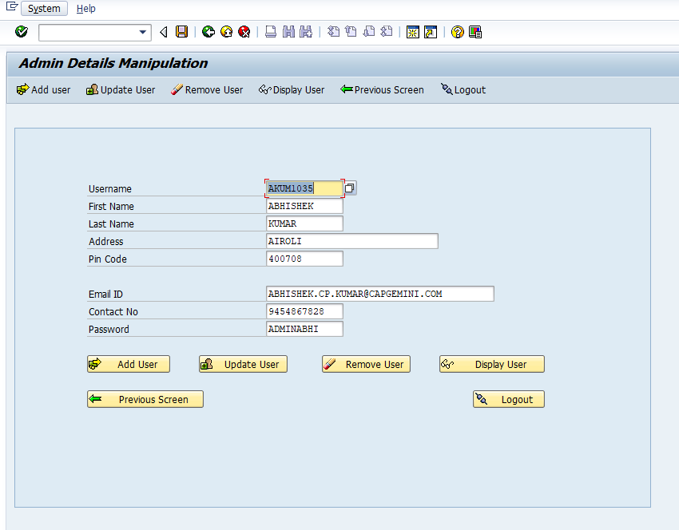

**Details of bookings using calendar:**

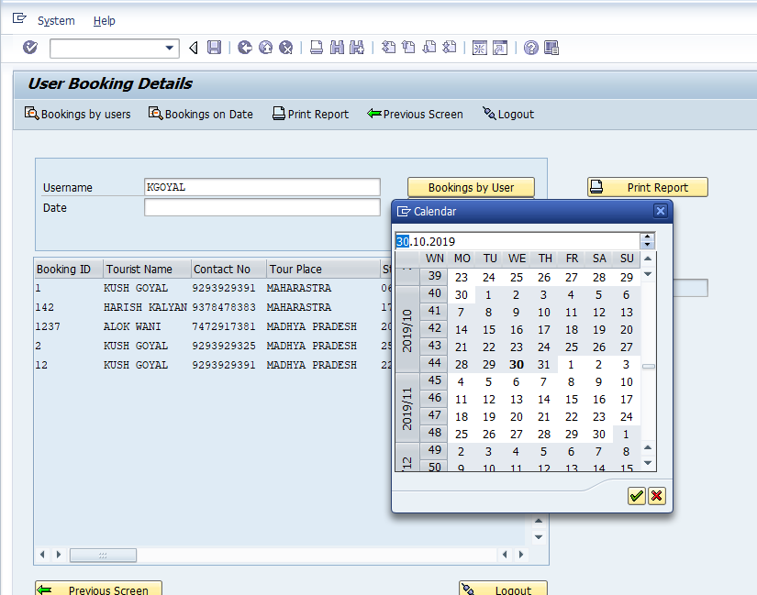

**Booking Details by Date and User:**

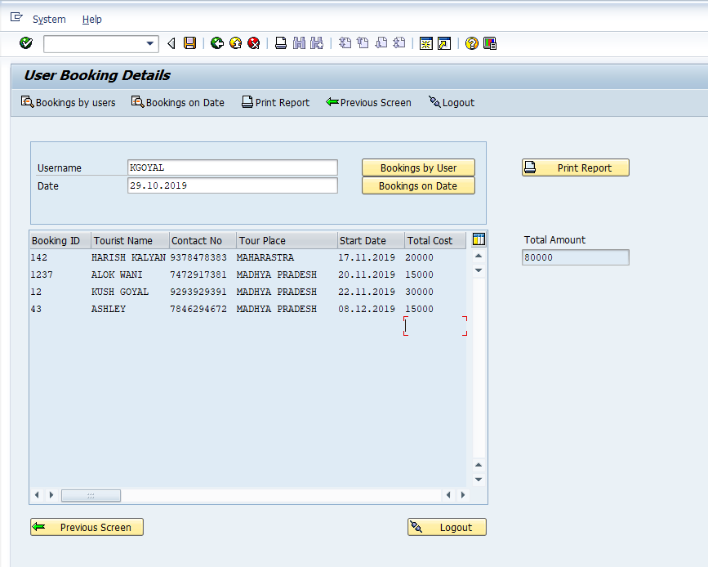

**Adobe form report:**

